**Worksheet 22 Doppler Effect Name:**

Relevant textbook sections covered: 20.7

**1)** The diagram below is supposed to illustrate the Doppler effect.



1

2

3

a) What do the points indicate? Why are the points evenly spaced? What are the circles, and how do they relate to the points?

b) The vertical lines indicate the radius of each wave front. Describe in words what a larger radius represents.

c) What is the wavelength that an observer receives at the **three locations**, larger than, smaller than, or the same as the original wavelength?

d) What change in frequency (‘pitch’) is observed by an observer at the three locations?

MOVING SOURCE, observer at rest



Moving

TOWARDS observer



Moving

AWAY from observer

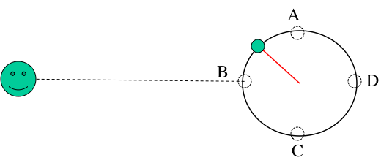

2. For the demo, I swing a sound generator (f = 600 Hz) attached to a 1.0 m long string around in a horizontal circle with a velocity of 10.5 m/s (100 revolutions per minute). What frequencies are detected by a student sitting in HEBB Theatre when the generator is at the positions A, B, C and D on the circle?

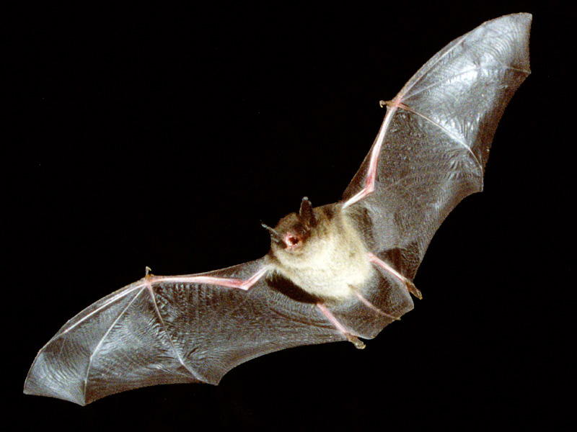

3. A bat flies toward a wall at a speed of 5.0 m/s. As it flies, the bat emits an ultrasonic sound wave with f = 40 kHz. What frequency does the bat hear in the reflected wave?

Source at rest, MOVING OBSERVER



Moving

TOWARDS source



Moving

AWAY FROM source

Source MOVING toward an observer AND observer MOVING toward a source

extra Doppler questions **HIGHLY recommended practice**

1) You have a summer job on a ship, the captain of the ship estimates that about 6 km ahead of the ship is an outcropping of land and asks you to use the sonar to check how fast the ship is approaching it. The ship's instruments tell you the ship is moving through still water at a speed of 31 km/hr but the captain cannot take any chances. A sonar signal is sent out with a frequency of 980 Hz, bounces off the underwater obstacle, and is detected on the ship.

**If the ship's speed indicator is correct, what frequency should you detect?**

The speed of sound in seawater is 1522 m/s.

2) Spectators at a race track hear the sound from a racecar engine changing as it passes by them. When the racecar approaches the spectators, the pitch is at 2000 Hz dropping to 1500 Hz when it moves away from the spectators.

**How fast is the racecar moving?**  (hint: COMPARE two equations)

3) A train is approaching the train station at velocity v1 relative to the ground in still air. The conductor sounds the train whistle, which emits a note with frequency f0. The sound of the whistle is heard by different observers: The conductor of the train hears a frequency fA; a person standing on the station platform watching the train approach hears a frequency fB; the conductor of a second train approaching the station from the other direction with velocity v2 hears a frequency fC; a passenger traveling on a slower train that has just been overtaken by the first train (and sees the first train move further away) hears frequency fD.

**Rank the frequencies heard by the observers (fA, fB, fC, fD) in order from the highest to the lowest frequency.**

Hint: DRAW a figure with all the different components of the question

4) A French submarine and a Canadian submarine move head-on, under water, during training exercises. The French submarine moves at 50 km/h and the Canadian sub at 70 km/h. The French submarine sends out a sonar signal at 1000 Hz. Sonar waves travel at 5470 km/h in water.

(a) What is the frequency detected by the Canadian sub?

(b) The sonar waves are reflected from the Canadian sub back to the French sub. What is the frequency of the reflected waves detected by the French sub?