Worksheet 20 Sound waves Name:
Relevant textbook sections covered: 20.5 and 20.6

1) A harmonic wave is traveling on a string with a speed of 0.45 m/s. The displacement of a portion of the string at x = 0.012 m is observed to vary with time according to the equation .
- What is the frequency of the wave?
- What are the values for the wavelength and the phase constant?
- Write a general equation for this wave i.e. equation for D(x,t).
HINT: Always begin these problems by writing down the wave equation:
D(x,t) = (D_{m})sin(kx + ωt +ϕ₀)

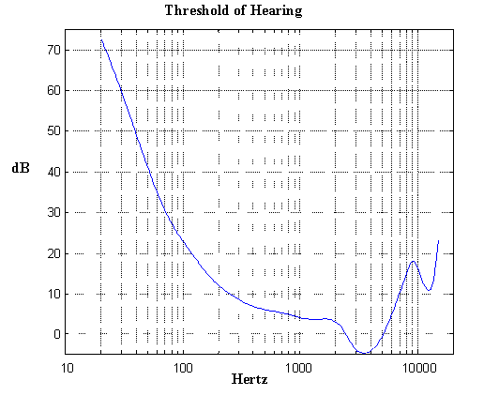
2) Human Hearing
The graph shows the threshold sensitivity of the human ear as a function of frequency. The y-axis shows the sound pressure level in dB at the location of the ear. The curve connects the same perceived loudness (‘phon’) at different frequencies.

At what frequency is the human ear most sensitive?

Write a sentence about how you can determine that BASED on the GRAPH.

3) Intensity and Sound Pressure Level.
You can easily experience that the loudness decreases if you move away from a sound source. This is mainly due to the spread of the sound energy in three dimensions.
a) Assuming that the wave fronts are three-dimensional spherical shells, how should two sound intensities compare if you are located 1.0 m and 3.0 m away from a sound source?

b) Assume that the sound level measured 1.0 m away from a loudspeaker is 110 dB. What will be the sound level at 3.0 m from the source?

GOOD PRACTICE: The sound level of a jet engine when it takes off is approximately 140 dB at a distance of 30 m. This is above the pain threshold for our ears. How far away do you have to stand to be safely below the pain threshold of 125 dB?

