**Worksheet 18 traveling waves Name:**

Relevant textbook sections covered: 20.2 & 20.3



1) Four snapshot graphs of a moving pulse are shown. Plot the history graph for the point x = 1.5 m. WRITE a sentence COMPARING the history graph with one snapshot graph.



2) What information can you determine from the two graphs below?

1) LABEL the graphs (snapshot OR history)

2) IDENTIFY which variables you could *potentially* solve for with information from the graphs.

VARIABLES: period (T), amplitude (Dm), frequency (f), angular frequency (ω), wavelength (λ), wave number (k), wave speed (v), particle speed, (vp)

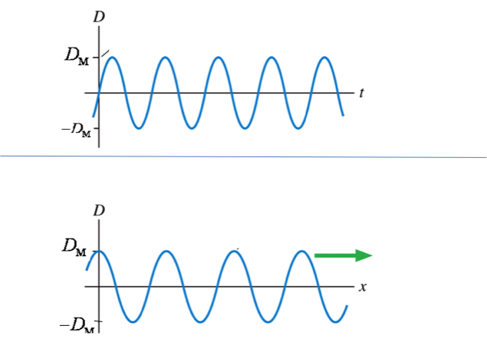

Variables from

GRAPH A

Variables I need BOTH graphs for



Variables from

GRAPH B

3) Consider the following equation

3) for a transverse wave on a string:

D(x, t) = 0.48 sin(5.6 x + 84 t)

D and x are in meters, t in seconds. Determine

1. Wavelength

1. Frequency f
2. Wave speed (to Left or Right?)

1. Amplitude

e) Max. & Min. speed of particles in wave

**GOOD PRACTICE:** A wave travelling along a stretched wire has the equation:

D(x,t) = (0.04m)sin(6.283x - 2.092t) *D(x,t) = Dmsin(kx - t +)*

1. Find the period, amplitude, wavelength, and wave speed

b) Sketch D(x,t) for the range 0<x<2m at t=0 and t=0.30 s



D(x,t)

D(x,t)

