Worksheet 17 traveling waves Name:
Relevant textbook sections covered: 20.1

1) Two children communicate through a “tin-can phone”, i.e., two cans tied together with a string (m = 40 g). The children stand 4.8 m apart, which pulls the string tight. When one child speaks, a transverse wave travels down the string, reaching the other child in 0.85s.
What is the tension in the string?

GOOD PRACTICE: During a vacation to Australia you watch the surfers and wonder how fast they might be going. The waves are huge, 5 m at least and you estimate that 10 surfboards in a row could fit between two wave crests.
You observe that the surfers paddle with their hands to get the board up to speed before standing up. So in order to catch a wave, their speed has to be close to the propagation speed of the waves. You notice that every 5 seconds, a wave rolls on to the beach.
a) How fast must the surfer paddle?

b) Do your estimates give you a reasonable speed for the surfers (convert to km/hr)?

2) Assume you pluck this combined string. Which of the following quantities are the same for the two strings? DEFEND your answer in either words or equations.
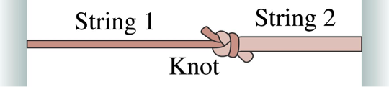
f, λ, v, T, μ

3) String 1 has a linear mass-density of 3.00 g/cm and string 2 has a linear mass density of 5.00 g/cm. They are under tension due to a hanging block of mass M = 500 g.

(a) Calculate the wave speed in each string.

(b) The block is now divided into two blocks of masses M₁ and M₂, as shown in the figure. Find M₁ and M₂ such that the wave speeds in the two strings are equal.

