Worksheet 19 wave equation and phase constant Name:
Relevant textbook sections covered: 20.2, 20.3, 20.4

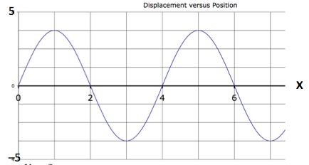
1) Which way is the wave traveling?
Shown here is a snapshot graph for t = 0 s.

a) Plot a series of snapshot graphs for the wave moving to the left and moving to the right.

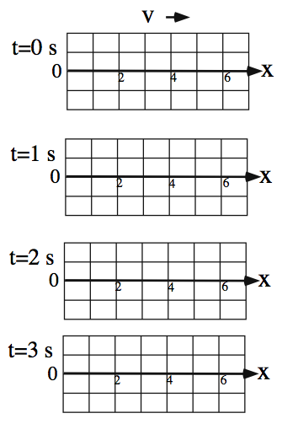
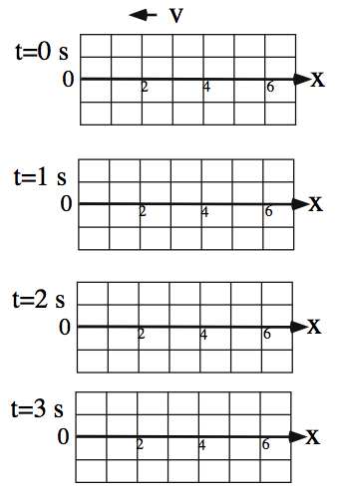

b) Use the point x = 0 in each graph to draw a corresponding history graph.
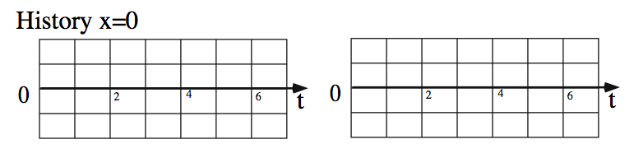

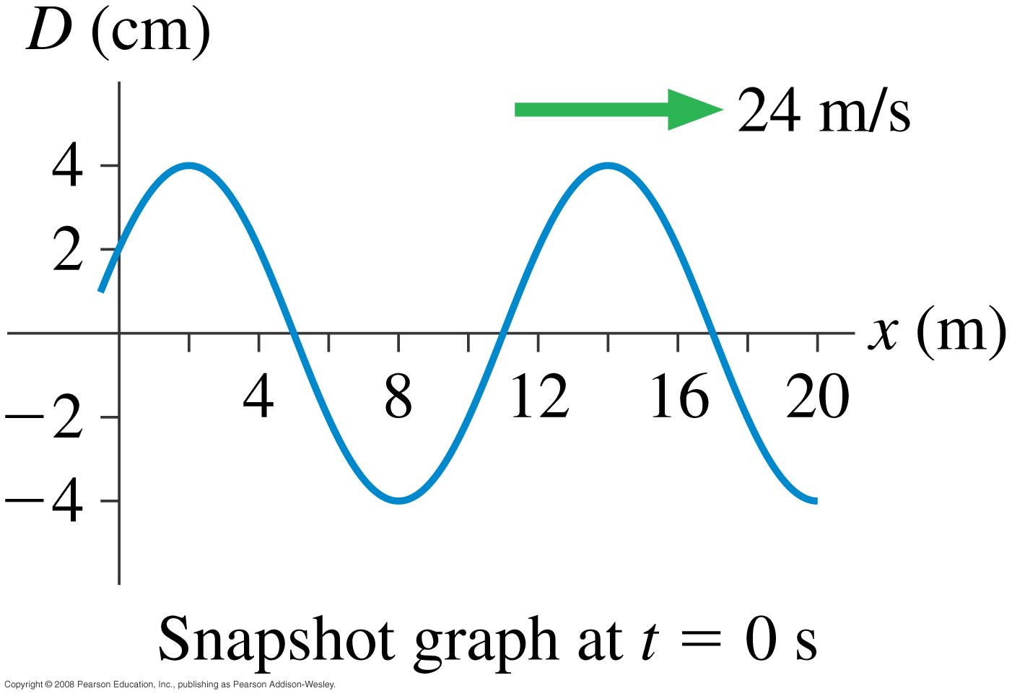
2) What are the amplitude, wavelength, frequency, and phase constant of the traveling wave in the figure? The wave is traveling to the right with a velocity v = 24 m/s.

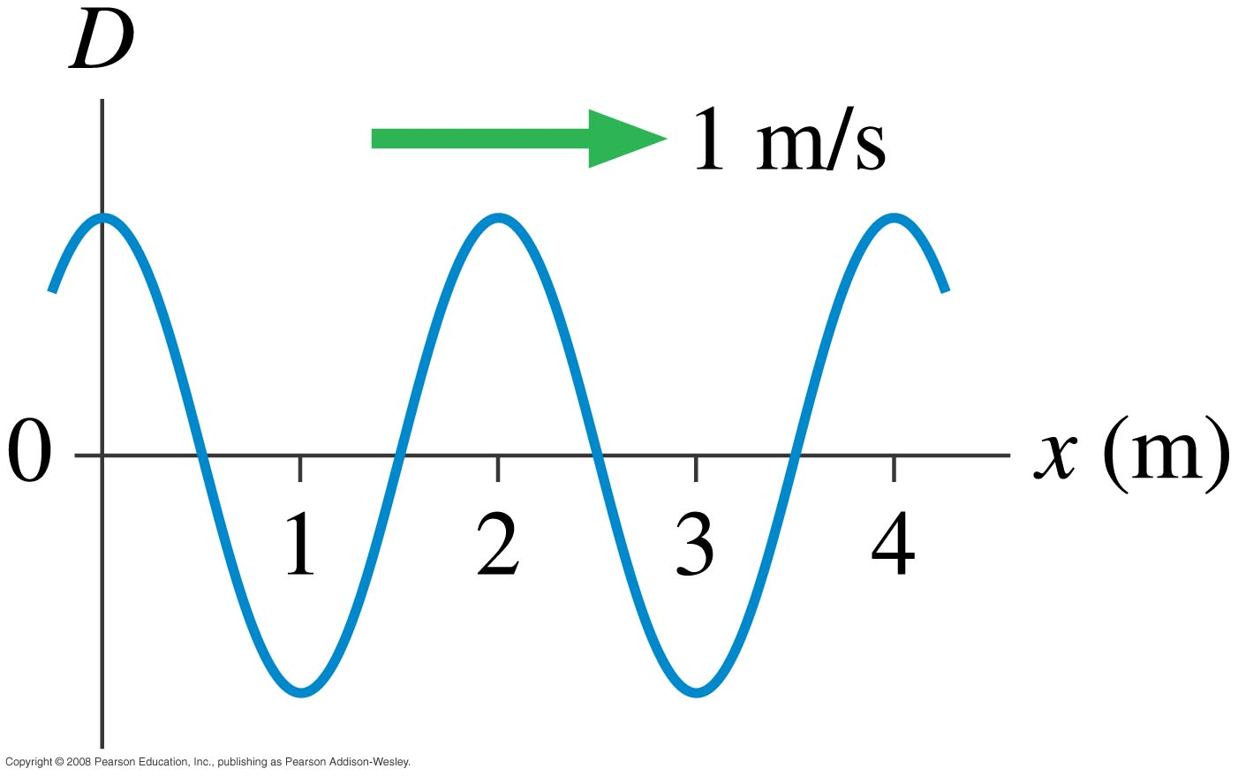
(cm)

3) Now consider a different wave with a
1
snapshot graph at t = 1 s. What is the phase
constant of this wave?

-1

