Worksheet 7 Equation of Continuity & fluid dynamics Name:
Relevant textbook sections covered: 15.5

1) How do ALL these variables fit together?
We have been learning about the relationship of pressure to force and area; and now we have the continuity equation relating area and velocity.
Let us now look at all the relationships between the variables:
Force (F), pressure (p), area (A), volume (V), velocity (v), and acceleration (a)
** BE CAREFUL with the upper and lower case letters for variables.
A₁
A₂
flow
The drawing shows a section
of a long round pipe in which
the diameter of the pipe changes.
Section 1 has a cross sectional
area A₁ and section 2 has area A₂.
Assume that water flows through
the pipe with a certain flow rate
Δm/Δt (= ρΔV/Δt).

What can you say about…
a) the flow rate as the fluid moves from the wide to the narrow section?
(increases, decreases, stays the same.)

b) the velocity of the fluid as it moves from the wide to the narrow section?
(increases, decreases, stays the same.)

c) If the diameters of the container are D₁ = 2 D₂, what is the relationship between the liquid’s velocity in the two sections? (write this as a ratio)

d) the acceleration of the fluid as it moves from the wide to the narrow section? (increases, decreases, stays the same.) hint: a = Δv/Δt

e) the force of the fluid as it moves from the wide to the narrow section?
(increases, decreases, stays the same.) hint: F = ma

TURN PAGE OVER
2) Conservation of energy in a flowing fluid
In high school, you learned about
- potential energy, PE = mgh
- kinetic energy, KE = 1/2mv²
- work: the external force needed to move an object some distance, W = F•s
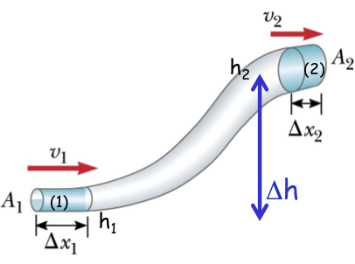
A fluid flows through a pipe that increases in height and changes in diameter (like in the figure).

(a) Write down the expression for the K and U at each opening of the pipe (1) and (2); substitute in m = ρV wherever possible

(b) Work on a flowing liquid can be written as W = ΔK + ΔU. Using the expressions from above, write the equation for work in a fluid.

(c) Does the total amount of energy change from point (1) to point (2)?
Explain your answer.

