Worksheet 5 Buoyancy Name:
Relevant textbook sections covered: 15.4

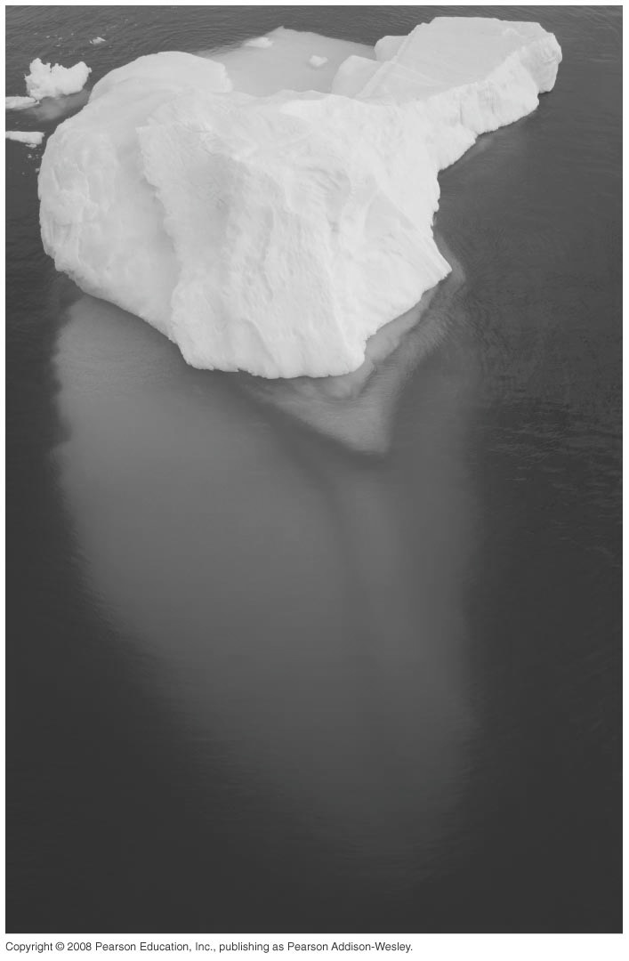
1) Of a floating iceberg, a fraction of approx. 10% is visible above the surface. If seawater has a density of 1025 kg/m³, what is the density of the iceberg?

TURN OVER THE PAGE FOR THE NEXT PROBLEM

2) Sink or SUP?
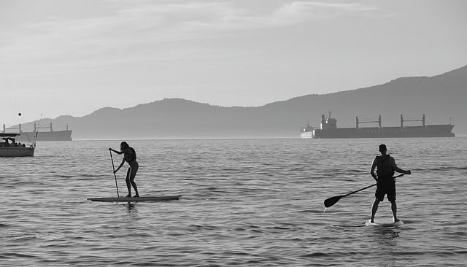
As a summer camp counselor, one day you take the kids to English Bay to rent some stand-up paddles (SUPs). All the kids want to go on the SUP together. You are worried that too many kids will make the SUP sink; luckily you know physics! How many kids are safe on the SUP?

Here’s some other info:
Assume each child has a mass of 30 kg.
The dimensions of the SUP are 3.00 m x 0.70 m x 0.12 m.
The SUP its own sits 0.08 m above the water line.

Think about: What are you comparing here? What components are in the force you are looking to solve?

