**Worksheet 4 Pressure differences & hydraulics** **Name:**

Relevant textbook sections covered: 15.2, 15.3, 15.4

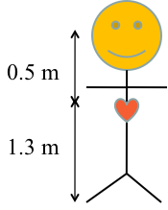

1) At the position (height) of your heart, the blood pressure is 13,340 Pa. The average density of blood is 1060 kg/m3 (“blood is thicker than water”).

1. When you are lying horizontally what is the blood pressure in your brain and feet? **Explain** your answer in WORDS.
2. Assume that you are standing up. Let us assume that your head is 0.5 m above your heart and your feet are 1.3 m below the heart. What is the blood pressure in your head and feet?
3. **Compare the two values and comment;** does this match with your everyday observations? (e.g., Why do people faint; why do your feet swell so much in an airplane?)

2a) Your finger can hold water inside a straw by closing off the top.

P1A

P0A

mg



A

B

C

Do you think the pressure at points A (inside the straw, near the finger), point B (at the liquid surface), and point C (at the bottom of the straw) is less than, the same, or greater than the atmospheric pressure?

**Explain your reasoning for each point.**

2b) Assume that the water column is 4 cm high inside the straw and the straw diameter is 3mm. Calculate the pressure inside the straw (above the liquid column)?

* Hint: Think about forces (see drawing).
* **Compare your answer to (2a);** **does your value make sense?**
* Do you think that the height of the water in the straw after it is pulled out of the glass will be smaller than, the same, or greater than the height of the water in the straw inside the glass?

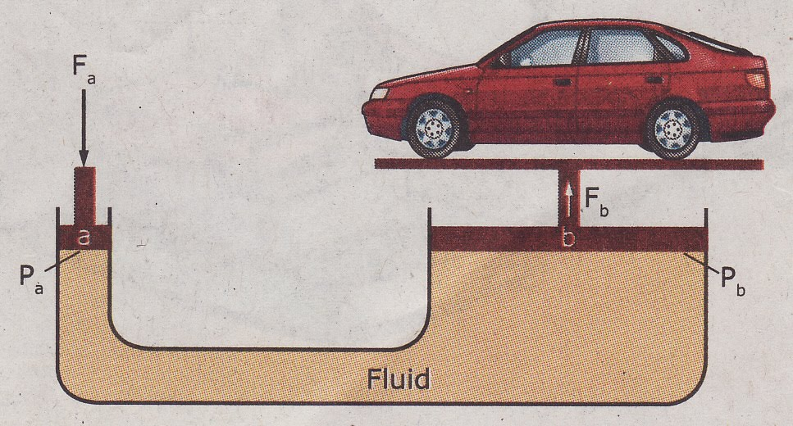3) Hydraulic Lift: In order to see how it works let’s look at two questions.

a) Assume that you want to lift up a 1000 kg car and that you can exert a force Fin = 500 N (by your weight). What is the approximate ratio A1/A2 of the two pipe areas necessary to hold the car in equilibrium near h = 0?

b) Approximately how many centimeters do you have to push down the input piston to lift the car 1.0 cm?